Grade 12 - Computer Science
Worksheet1 – Chapter14

Question 1:
What are DDL and DML?
Or
Differentiate between Data Definition Language and Data Manipulation Language.
Question 2:
Differentiate between SQL commands DROP TABLE and DROP VIEW.
Question 3:
Give the SQL statement to create a table STUDENT with Roll Number, Name, Age and Marks.
Question 4:
Write a query on the SALESPEOPLE table, whose output will exclude all salespeople with a rating >=100, unless they are located in Delhi.
Question 5:
Create a table named PROGRAMMERS with the following structure:
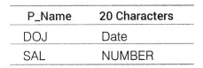
(i) Display the name of the programmer, which has the highest salary.
(ii) UPDATE the salary of all programmer by 2000, whose name start with letter ‘R’.
Question 6:
Answer the questions (a) and (b) on the basis of the following tables SHOPPE and ACCESSORIES. All India 2014
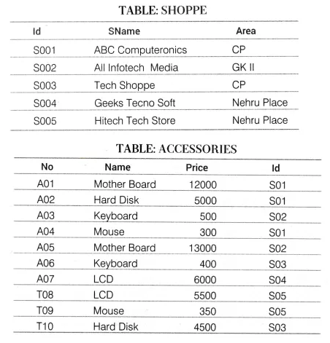
(a) Write the SQL queries:
(i) To display Name and Price of all the Accessories in ascending order of their Price.
(ii) To display Id and SName of all Shoppe located in Nehru Place.
(iii) To display Minimum and Maximum Price of each Name of Accessories.
(iv) To display Name, Price of all Accessories and their respective SName, where they are available.
(b) Write the output of the following SQL commands:
(i) SELECT DISTINCT NAME FROM ACCESSORIES WHERE PRICE>=5000;
(ii) SELECT AREA, COUNT(*) FROM SHOPPE GROUP BY AREA;
(iii) SELECT COUNT (DI ST INCT AREA) FROM SHOPPE:
(iv) SELECT NAME, PRICE*0.05 DISCOUNT FROM ACCESSORIES WHERE SNO IN ('S02'.'S03');

Question 7:
Write SQL queries for (a) to (f) and write the output for the SQL queries mentioned in (g) parts (i) to (iv) on the basis of tables ITEMS and TRADERS. Delhi 2013
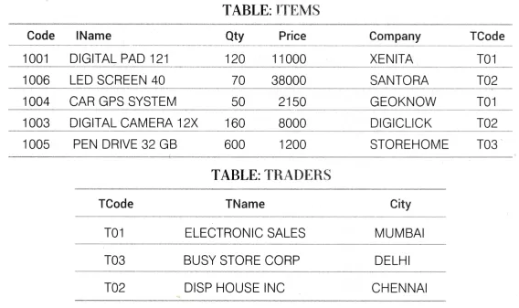
(a) To display the details of all the items in ascending order of item names (i.e. I NAME).
(b) To display item name and price of all those items, whose price is in the range of 10000 and 22000 (both values inclusive).
(c) To display the number of items, which are traded by each trader. The expected output of this query should be:
T01 2
T03 1
T02 2
(d) To display the Price, item name (i.e. IName) and quantity (i.e. Qty) of those items, which have quantity more than 150.
(e) To display the names of those traders, who are either from DELHI or from MUMBAI.
(f) To display the name of the companies and the name of the items in descending order of company names.
(g) Obtain the outputs of the following SQL queries based on the data given in tables ITEMS and TRADERS above.
(i) SELECT MAX(Price), MIN(Price) FROM ITEMS;
(ii) SELECT Price * Qty AMOUNT .
FROM ITEMS WHERE Code=1004;
(iii) SELECT DISTINCT TCode FROM ITEMS;
(iv) SELECT IName, TName
FROM ITEMS I, TRADERS T
WHERE I.TCode = T.TCode AND Qty < 100;
Question 8:
Write SQL queries for (a) to (f) and write the outputs for (g) parts (i) to (iv) on the basis of tables APPLICANTS and COURSES. Delhi 2013C
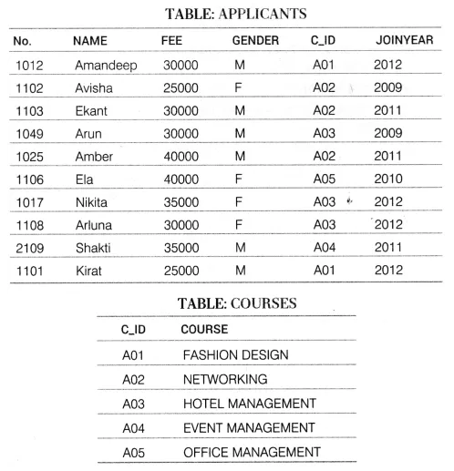
(a) To display NAME, FEE, GENDER, JOINYEAR about the APPLICANTS, who have joined before 2010.
(b) To display the names of applicants, who are paying FEE more than 30000.
(c) To display the names of all applicants in ascending order of their joinyear.
(d) To display the year and the total number of applicants joined in each year from the table APPLICANTS.
(e) To display the CJD and the number of applicants registered in the course from the APPLICANTS table.
(f) To display the applicant’s name with their respective course’s name from the tables APPLICANTS and COURSES.
(g) Give the output of the following SQL statements:
(i) SELECT NAME, JOINYEAR FROM APPLICANTS WHERE GENDER =' F' AND C_ID= ’ A02 ’ ;
(ii) SELECT MIN (JOI NYEAR) FROM APPLICANTS WHERE GENDER = ' M' ;
(iii) SELECT AVG(FEE) FROM APPLICANTS WHERE C_ID='A01 ’ OR C_ID='A05’;
(iv) SELECT SUM( FEE), C_ID FROM APPLICANTS GROUP BY C_ID HAVING C0UNT(*)=2;

Question 9:
Consider the following tables CUSTOMER and ONLINESHOP. Write SQL commands for the statements (a) to (d) and give outputs for SQL queries (e) to (h). Delhi 2012C
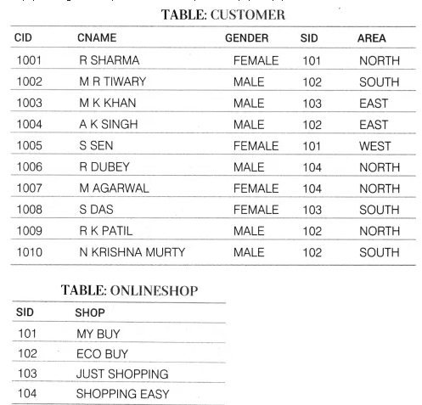
(a) To display CNAME, AREA of all female customers from CUSTOMER table.
(b) To display the details of all the CUSTOMERS in ascending order of CNAME within SID.
(c) To display the total number of customers for each AREA from CUSTOMER table.
(d) To display CNAME and corresponding SHOP from CUSTOMER table and ONLINESHOP table.
(e) SELECT COUNT(*), GENDER FROM CUSTOMER GROUP BY GENDER;
(f) SELECT COUNT(*) FROM ONLINESHOP;
(g) SELECT CNAME FROM CUSTOMER WHERE CNAME LIKE 'L%';
(h) SELECT DISTINCT AREA FROM CUSTOMER;

Question 10:
Consider the following tables CARDEN and CUSTOMER and answer (a) and (b) parts of this questions: All India 2012
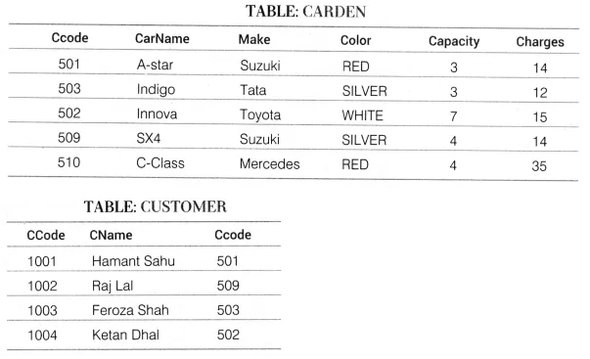
(a) Write SQL commands for the following statements:
(i) To display the name of all the SILVER colored cars.
(ii) To display name of Car, Make and sitting Capacity of cars in descending order of their sitting Capacity.
(iii) To display the highest Charges at which a vehicle can be hired from CARDEN.
(iv) To display the Customer name and the corresponding name of the Cars hired by them.
(b) Give the output of the following SQL queries:
(i) SELECT COUNT(DISTINCT Make) FROM CARDEN;
(ii) SELECT MAX(Charges), MIN (Charges) FROM CARDEN;
(iii) SELECT COUNT(*) Make FROM CARDEN;
(iv) SELECT CarName FROM CARDEN WHERE Capacity = 4;
Question 11:
Consider the following tables EMPLOYEE and SALGRADE and answer (a) and (b) parts of this question: All India 2012
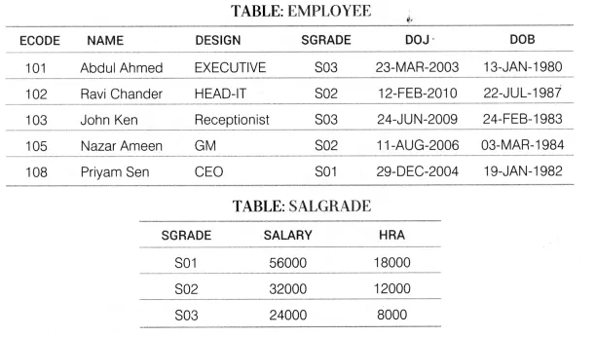
(a) Write SQL commands for the folio wing statements:
(i) To display the details of all the EMPLOYEE in descending order of DOJ.
(ii) To display NAME and DESIGN of those EMPLOYEES, whose SGRADE is either S02 or S03.
(iii) To display the content of all the EMPLOYEES, whose DOJ is in between ’09-FEB-2006′ and ’08-AUG-2009′.
(iv) To add a new row in the EMPLOYEE table with the following:
109, ‘Harish Roy’, ‘HEAD-IT’, ‘S02′, ’09-SEP-2007′, ’21 -APR-1983’.
(b) Give the output of the following SQL queries:
(i) SELECT COUNT (SGRADE) , SGRADE FROM EMPLOYEE GROUP BY SGRADE;
(ii) SELECT MIN( DOB), MAX(DOJ) FROM EMPLOYEE;
(iii) SELECT NAME, SALARY FROM EMPLOYEE E, SALGRADE S
WHERE E.SGRADE=S.SGRADE AND E.EC0DE<103;
(iv) SELECT SGRADE, SALARY+HRA FROM SALGRADE
WHERE SGRADE='S02';
Question 12:
Consider the following tables STORE and SUPPLIERS and answer (a) and (b) parts of this questions: Delhi 2010
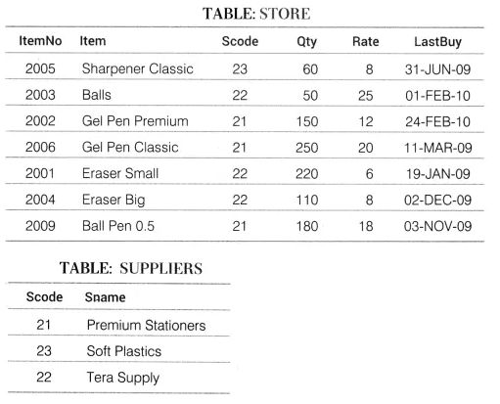
(a) Write SQL commands for the following statements:
(i) To display details of all the items in the STORE table in ascending order of LastBuy.
(ii) To display ItemNo and Item name of those items from STORE table, whose Rate is more than Rs. 15.
(Hi) To display the details of those items whose Supplier code (Scode) is 22 or Quantity in Store (Qty) is more than 110 from the table STORE.
(iv) To display minimum rate of items for each Supplier individually as per Scode from the table STORE.
(b) Give the output of the following SQL queries:
(i) SELECT COUNT(DISTINCT Scode) FROM STORE;
(ii) SELECT Rate * Qty FROM STORE WHERE ItemNo = 2004;
(iii) SELECT Item, Sname FROM STORE S, SUPPLIERS P
WHERE S.Scode=P.Scode AND ItemNo=2006;
(iv) SELECT MAX( LastBuy) FROM STORE;
Question 13:
Consider the following tables STUDENT and STREAM. Write SQL commands for the statements (a) to (d) and give outputs for SQL queries (e) to (h). Delhi 2009C
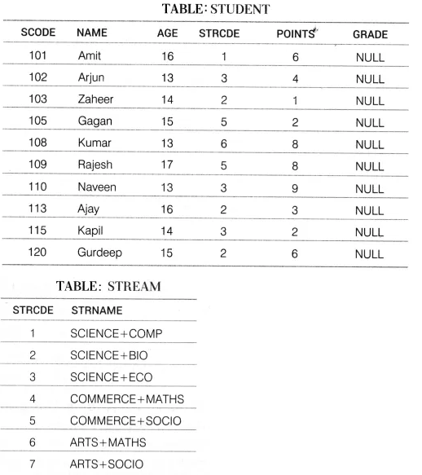
(a) To display the name of streams in alphabetical order from table STREAM.
(b) To display the number of students whose POINTS are more than 5.
(c) To update GRADE to A’for all those students, who are getting more than 8 as POINTS.
(d) ARTS+MATHS stream is no more available. Make necessary change in table STREAM.
(e) SELECT SUM(POINTS) FROM STUDENT WHERE AGE > 14;
(f) SELECT STRODE, MAX(POINTS) FROM STUDENT GROUP BY STRODE
HAVING SCODE BETWEEN 105 AND 130;
(g) SELECT AVG(AGE) FROM STUDENT WHERE SCODE IN (102, 105, 110, 120);
(h) SELECT COUNT(STRNAME) FROM STREAM WHERE STRNAME LIKE "SCI%";
Question 14:
Consider the following tables GARMENT and FABRIC. Write SQL commands for the statements (a) to (d) and give outputs for SQL queries (e) to (h). Delhi 2009
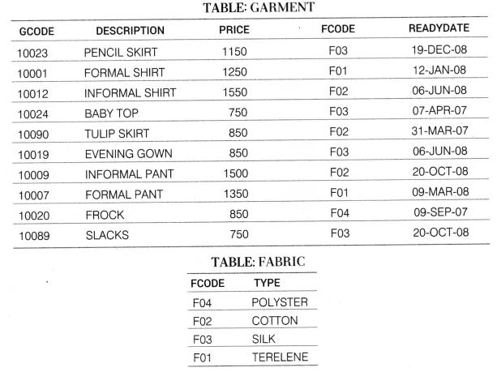
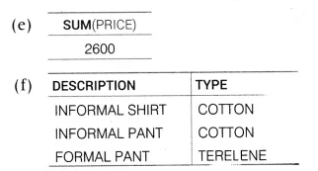
(a) To display GCODE and DESCRIPTION of each GARMENT in descending order ofGCODE.
(b) To display the details of all the GARMENTS, which have READYDATE in between 08-DEC-07 and 16-JUN-08 (inclusive of both the dates).
(c) To display the average PRICE of all the GARMENTS. Which are made up of FABRIC with FCODE as F03.
(d) To display FABRIC wise highest and lowest price of GARMENTS from GARMENT table. (Display FCODE of each GARMENT alongwith highest and lowest price.)
(e) SELECT SUM(PRICE) FROM GARMENT WHERE FCODE = 'F01’;
(f) SELECT DESCRIPTION, TYPE FROM GARMENT, FABRIC
WHERE GARMENT.FCODE = FABRIC.FCODE AND GARMENT.PRICE >=1260:
(g) SELECT MAX( FCODE) FROM FABRIC;
(h) SELECT COUNT(DISTINCT PRICE) FROM GARMENT;
Question 15:
Consider the following tables. Write SQL commands for the statements (a) to (d) and give outputs for SQL queries (e) to (h).
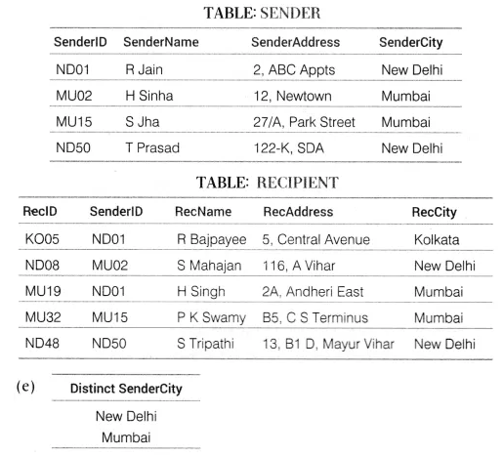
(a) To display the names of all Senders from Mumbai.
(b) To display the RecID, SenderName, SenderAddress, RecName, RecAddressfor every Recipient.
(c) To display Recipient details in ascending order of RecName.
(d) To display number of Recipients from each City.
(e) SELECT DISTINCT SenderCity FROM SENDER;
(f) SELECT A.SenderName, B.RecName FROM SENDER A, RECIPIENT B
WHERE A.Sender ID=B.Sender ID AND B.RecCity = 'Mumbai';
(g) SELECT RecName, RecAddress FROM RECIPIENT WHERE RecCity NOT IN ('Mumbai', 'Kolkata');
(h) SELECT RecID, RecNam FROM RECIPIENT
WHERE SenderlD = 'MU02' OR SenderlD = ' ND50 ’ ;

